## **Diet Quality Questionnaire (DQQ)**

## **Indicator Guide**

© Global Diet Quality Project

Contact: Anna Herforth, [aherforth@hsph.harvard.edu](mailto:aherforth@hsph.harvard.edu)

Version 7, updated Oct 2022



**DQQ Overview**

The **Diet Quality Questionnaire (DQQ)** is a standardized tool to collect indicators of ***dietary adequacy***, including the minimum dietary diversity for women (MDD-W) indicator[1], and All-5, as well as indicators of ***protection of health against noncommunicable diseases (NCDs)***, including NCD-Protect, NCD-Risk, and the global dietary recommendations score (GDR).[2] The DQQ was developed to enable population-level diet quality monitoring. It was not developed to assess dietary intake of individuals. The DQQ can be used to assess dietary patterns and trends in the general population; separate companion questionnaires are designed for infants and young children under age 2 years.

**Purpose of this Indicator Guide**

This analytical guide defines indicators that can be derived from the diet quality questionnaire (DQQ) and shows how to calculate the indicators from DQQ data**.** These indicators are valid at population level.

|  |
| --- |
| **DQQ Food Groups** |

1. Foods made from grains

2. Whole grains

3. White roots, tubers, and plantains

4. Pulses

5. Vitamin A-rich orange vegetables

6. Dark green leafy vegetables

7. Other vegetables

8. Vitamin A-rich fruits

9. Citrus

10. Other fruits

11. Baked / grain-based sweets

12. Other sweets

13. Eggs

14. Cheese

15. Yogurt

16. Processed meats

17. Unprocessed red meat (ruminant)

18. Unprocessed red meat (non-ruminant)

19. Poultry

20. Fish and seafood

21. Nuts and seeds

22. Packaged ultra-processed salty snacks

23. Instant noodles

24. Deep fried foods

25. Fluid milk

26. Sweet tea / coffee / cocoa

27. Fruit juice and fruit-flavored drinks

28. Sugar-sweetened beverages (soft drinks, energy drinks, sports drinks)

29. Fast food

# **Indicators**

*Indicators are positive (higher score is better), except where marked with (-) (higher score is worse).*

***Main DQQ diet quality indicators***

1. MDD-W (0/1) / Food Group Diversity Score (FGDS) (0-10)
2. All-5 (0/1): Consumed all five recommended food groups: at least one vegetable, at least one fruit, at least one pulse, nut or seed, at least one animal-source food, and at least one starchy staple.
   1. At least one vegetable
   2. At least one fruit
   3. At least one pulse, nut, or seed
   4. At least one animal-source food (ASF)
   5. At least one starchy staple
3. NCD-Protect[3] (0-9)
4. NCD-Risk[4] (0-9) (-)
5. Global Dietary Recommendations (GDR) Score (-9- 9, or 0-18)
6. DQQ diet quality score (validation underway)

***Diet quality indicators for the general population aligned with WHO and UNICEF indicators for infant and young child feeding***

*Binary; expressed as proportion of population*

1. Zero vegetable or fruit consumption (-)
2. Animal-source food consumption
3. Sweet beverage consumption (-)
   1. Sugar-sweetened soft drink consumption (-)
4. Sweet foods consumption (-)
5. Salty or fried snack consumption (-)

***Indicators of individual WHO recommendations***

*Binary; expressed as proportion of population*

*\*Indicators marked with an asterisk have been validated in two countries, Brazil and the United States. Validation in additional countries and regions is underway.*

1. Whole grain consumption
2. Pulse consumption
3. Nuts/seeds consumption
4. Processed meat consumption (-)
5. At least 400 g of fruits and vegetables*
6. At least 25 g of fiber*
7. More than 10% of energy from free sugars* (-)
8. More than 10% of energy from saturated fats* (-)

***Other binary indicators***

1. % consuming each food group or combinations of food groups
   1. At least one vegetable or fruit
   2. Packaged ultra-processed salty snacks, instant noodles, or fast food

# **Main DQQ Diet Quality Indicators**

# MDD-W & Food Group Diversity Score (FGDS)

**An indicator of micronutrient adequacy**

**Minimum Dietary Diversity for Women of Reproductive Age (MDD-W)** is achieved when ≥5 out of 10 specific food groups are consumed by an individual over the course of a day. Women in low- and middle-income countries who do not meet the MDD-W are at higher risk of inadequate micronutrient intakes.

A score of 5 or more indicates higher likelihood of adequate micronutrient intake for women of reproductive age (age 15-49 years). MDD-W is expressed as a binary score (1/0), and can therefore be used to identify the percentage of a population who is meeting the MDD-W. This indicator is only validated for women age 15-49 years in low- and middle-income countries.

When these food groups are applied to the general population, the indicator is called the **Food Group Diversity Score (FGDS**). It is not validated as an indicator of nutrient adequacy for the general population, but gender equity of food group diversity can be assessed. The FGDS is a semi-continuous score (0-10), expressed as the average score out of 10 for the population.

A YES response to ANY of the question numbers confers a YES response to the MDD-W / FGDS food group. For example, if a respondent answered YES to **any or all** of three questions (question 1, question 2, or question 3), their response is scored as 1 point.

**Food Group Diversity Score (FGDS**)

1 point for each “YES” answer to the following food groups:

|  |  |  |
| --- | --- | --- |
| **MDD-W Food group** | **DQQ Question numbers** | **Possible points** |
| *Grains, white roots and tubers, and plantains* | 1, 2, 3 | 1 |
| *Pulses (beans, peas and lentils)* | 4 | 1 |
| *Nuts and seeds* | 21 | 1 |
| *Dairy* | 14, 15, 25 | 1 |
| *Meat, poultry and fish* | 16, 17, 18, 19, 20 | 1 |
| *Eggs* | 13 | 1 |
| *Dark green leafy vegetables* | 6* | 1 |
| *Other vitamin A-rich fruits and vegetables* | 5, 8 | 1 |
| *Other vegetables* | 7* | 1 |
| *Other fruits* | 9, 10* | 1 |
| *TOTAL* |  | SUM (0-10) |

*Note that these groups may be asked in two or more questions (e.g. 6.1 and 6.2).

**MDD-W (0/1)**

Validated as a proxy indicator for micronutrient adequacy for women age 15-49 years.

|  |  |  |
| --- | --- | --- |
| *TOTAL FGDS (see table just above)* |  |  |
|  | *If score ≥ 5* | 1 |
|  | *If score <5* | 0 |

## All-5: Consumed all five recommended food groups

**An indicator of food group adequacy**

Proportion of the total population consuming all five food groups typically recommended for daily consumption in food-based dietary guidelines around the world: fruits; vegetables; pulses, nuts, or seeds; animal-source foods; and starchy staples. A score of 5 indicates minimal adherence to dietary guidelines, because people who did not consume the food groups definitely did not meet dietary guidelines. (It is therefore a minimum bar, because many people who consumed all five food groups still may not have met dietary guidelines in terms of quantities consumed.)

Variants of this indicator can be adopted for specific national food-based dietary guidelines with different food group requirements.

A score of less than 5 indicates that not all five recommended food groups were consumed (binary score: 1/0). All-5 is expressed as the percent of the population consuming all five recommended food groups the previous day or night.

1 point for each “YES” answer to the following aggregate food groups:

|  |  |  |
| --- | --- | --- |
| **Aggregate Food group** | **DQQ Question numbers** | **Possible points** |
| *Starchy staples* | 1,2,3 | 1 |
| *Vegetables* | 5,6*,7* | 1 |
| *Fruits* | 8,9,10* | 1 |
| *Pulses, nuts and seeds* | 4, 21 | 1 |
| *Animal-source foods* | 13,14,15,17,18,19,20,25 | 1 |
| *TOTAL* |  | SUM (0-5) |
|  | *If score = 5* | 1 |
|  | *If score <5* | 0 |

*Note that these groups may be asked in two or more questions (e.g. 6.1 and 6.2).

Note: Processed meats, instant noodles, and packaged ultra-processed salty snacks are excluded from these food groups, because they are not recommended in dietary guidelines.

Each food group component of this score may be useful to examine separately:

## At least one vegetable

A score of 1 indicates that at least one vegetable was consumed, and is expressed as the percent of the population consuming this food group.

1 point for each “YES” answer to the following aggregate food groups:

|  |  |  |
| --- | --- | --- |
| **Aggregate Food group** | **DQQ Question numbers** | **Possible points** |
| *Vegetables* | 5,6*,7* | 1 |
| *TOTAL* |  | SUM (0-1) |

*Note that these groups may be asked in two or more questions (e.g. 6.1 and 6.2).

## At least one fruit

A score of 1 indicates that at least one vegetable was consumed, and is expressed as the percent of the population consuming this food group.

1 point for each “YES” answer to the following aggregate food groups:

|  |  |  |
| --- | --- | --- |
| **Aggregate Food group** | **DQQ Question numbers** | **Possible points** |
| *Fruits* | 8,9,10* | 1 |
| *TOTAL* |  | SUM (0-1) |

*Note that these groups may be asked in two or more questions (e.g. 6.1 and 6.2).

## At least one pulse, nut or seed

A score of 1 indicates that at least one pulse, nut or seed was consumed, and is expressed as the percent of the population consuming this food group.

1 point for each “YES” answer to the following aggregate food groups:

|  |  |  |
| --- | --- | --- |
| **Aggregate Food group** | **DQQ Question numbers** | **Possible points** |
| *Pulses, nuts and seeds* | 4,21 | 1 |
| *TOTAL* |  | SUM (0-1) |

## At least one animal-source food (ASF)

A score of 1 indicates that at least one recommended ASF food was consumed, and is expressed as the percent of the population consuming this food group. (Excludes processed meats, because these are not recommended.)

1 point for each “YES” answer to the following aggregate food groups:

|  |  |  |
| --- | --- | --- |
| **Aggregate Food group** | **DQQ Question numbers** | **Possible points** |
| *Animal-source foods* | 13,14,15,17,18,19,20,25 | 1 |
| *TOTAL* |  | SUM (0-1) |

## At least starchy staple

A score of 1 indicates that at least one starchy staple was consumed, and is expressed as the percent of the population consuming this food group.

1 point for each “YES” answer to the following aggregate food groups:

|  |  |  |
| --- | --- | --- |
| **Aggregate Food group** | **DQQ Question numbers** | **Possible points** |
| *Starchy staples* | 1,2,3 | 1 |
| *TOTAL* |  | SUM (0-1) |

## NCD-Protect score

*previously published as “GDR-Healthy”*

**An indicator of dietary factors protective against NCDs** (articulated by WHO):

* At least 400g of fruits and vegetables per day
* Whole grains, pulses, and nuts or seeds
* At least 25g of fiber per day

The NCD-Protect score is a score with a range from 0 to 9. It is a sub-component of the GDR score, and reflects adherence to global dietary recommendations on healthy components of the diet. The NCD-Protect score is based on food consumption from 9 healthy food groups during the past day and night. A higher score indicates inclusion of more health-promoting foods in the diet, and correlates positively with meeting global dietary recommendations. It is expressed as the average score for the population.

1 point for each “YES” answer to the following food groups:

| **Food group** | **DQQ Question numbers** | **Possible points** |
| --- | --- | --- |
| *Whole grains* | 2 | 1 |
| *Pulses* | 4 | 1 |
| *Nuts and seeds* | 21 | 1 |
| *Vitamin A-rich orange vegetables* | 5 | 1 |
| *Dark green leafy vegetables* | 6* | 1 |
| *Other vegetables* | 7* | 1 |
| *Vitamin A-rich fruits* | 8 | 1 |
| *Citrus* | 9 | 1 |
| *Other fruits* | 10* | 1 |
| *TOTAL* |  | SUM (0-9) |

*Note that these groups may be asked in two or more questions (e.g. 6.1 and 6.2).

## NCD-Risk score (-)

*previously published as “GDR-Limit”*

**An indicator of dietary factors for NCDs** (articulated by WHO and derived from WHO

International Agency for Research on Cancer):

* Less than 10% (ideally less than 5%) of total energy from free sugars
* Less than 10% of total energy from saturated fat, and less than 30% from total fat
* Less than 5g of salt per day
* Little if any processed meat, and red meat limited to no more than 350–500g per week.

**The NCD-Risk score is also a proxy for ultra-processed food intake.** A higher NCD-Risk score is closely related to higher ultra-processed food consumption.

The NCD-Risk score is a score with a range from 0 to 9. It is a sub-component of the GDR score, and reflects adherence to global dietary recommendations on components of the diet to limit or avoid. A higher score indicates higher consumption of foods and drinks to avoid or limit, and correlates negatively with meeting global dietary recommendations. The NCD-Risk score is based on food consumption from 8 food groups to limit or avoid during the past day and night (one food group, processed meat, is double weighted). This is a negative indicator, and is expressed as the average score for the population.

1 point for each “YES” answer to the following food groups, except processed meats receive a double weight:

|  |  |  |
| --- | --- | --- |
| **Food group** | **DQQ Question numbers** | **Possible points** |
| *Soft drinks (sodas)* | 28 | 1 |
| *Baked / grain-based sweets* | 11 | 1 |
| *Other sweets* | 12 | 1 |
| *Processed meat* | 16 | 2 |
| *Unprocessed red meat* | 17, 18 | 1 |
| *Deep fried food* | 24 | 1 |
| *Fast food & Instant noodles* | 23, 29 | 1 |
| *Packaged ultra-processed salty snacks* | 22 | 1 |
| *TOTAL* |  | SUM (0-9) |

## Global Dietary Recommendations (GDR) score

The GDR score is a score with a range from 0 to 18 that indicates adherence to global dietary recommendations, which include dietary factors protective against non-communicable diseases. (**See Annex 1**). The higher the GDR score, the more recommendations are likely to be met. The GDR score is based on food group consumption during the past day and night.

The GDR score is calculated as follows: **NCD-Protect - NCD-Risk + 9 = GDR score**

It is expressed as the average score for the population.

## DQQ Diet Quality Score

Coming soon (validation underway)

**Diet quality indicators for the general population that are aligned with WHO and UNICEF indicators for infant and young child feeding[5]**

## Zero vegetable or fruit consumption (-)

This indicator reflects the proportion of the population who did not consume vegetables or fruits in the previous day, let alone meeting the recommendation to consume 400 grams of fruits and vegetables daily.

A score of 0 indicates that no fruit or vegetable was consumed. This is a negative indicator, and is expressed as the percent of the population not consuming these food groups.

1 point for each “YES” answer to the following aggregate food groups:

|  |  |  |
| --- | --- | --- |
| **Aggregate Food group** | **DQQ Question numbers** | **Possible points** |
| *Fruits and Vegetables* | 5,6*,7*, 8,9,10* | 1 |
| *TOTAL* |  | SUM (0-1) |

*Note that these groups may be asked in two or more questions (e.g. 6.1 and 6.2).

## Animal-source food (ASF) consumption

A score of 1 indicates that at least one recommended ASF food was consumed, and is expressed as the percent of the population consuming this aggregate food group. (Excludes processed meats, because these are not recommended.)

1 point for each “YES” answer to the following aggregate food groups:

|  |  |  |
| --- | --- | --- |
| **Aggregate Food group** | **DQQ Question numbers** | **Possible points** |
| *Animal-source foods* | 13,14,15,17,18,19,20,25 | 1 |
| *TOTAL* |  | SUM (0-1) |

## Sweet beverage consumption (-)

A score of 1 indicates that any sweet beverage (soda, energy drinks, sports drinks, fruit drinks, fruit juice, sweetened tea/milk/coffee) was consumed. This is a negative indicator, and is expressed as the percent of the population consuming this aggregate food group.

1 point for each “YES” answer to the following aggregate food groups:

|  |  |  |
| --- | --- | --- |
| **Aggregate Food group** | **DQQ Question numbers** | **Possible points** |
| *Sweet beverages* | 26,27,28 | 1 |
| *TOTAL* |  | SUM (0-1) |

## Sugar-sweetened soft drink consumption (-)

This indicator shows the proportion of the total population who consumed a sugar-sweetened soft drink (soda, energy drinks, or sports drinks) in the previous day. Soft drinks are strongly associated with excess sugar consumption and risk of NCDs, and are also a marker of dietary and nutrition transitions. For adults, the indicator excludes sweetened coffee, tea, and milk drinks and fruit juice and fruit drinks. While for children, consumption of any sweet beverage is not recommended, for adults, sweetened tea and coffee are often traditionally consumed and are unlikely to have policy relevance, while consumption of soft drinks reflects ultra-processed beverages and has clear policy relevance related to food environment and diet and nutrition transitions.

A score of 1 indicates that sugar-sweetened soda, energy drinks, or sports drinks were consumed. This is a negative indicator, and is expressed as the percent of the population consuming this food group.

1 point for each “YES” answer to the following aggregate food groups:

|  |  |  |
| --- | --- | --- |
| **Aggregate Food group** | **DQQ Question numbers** | **Possible points** |
| *Sodas, energy drinks, sports drinks* | 28 | 1 |
| *TOTAL* |  | SUM (0-1) |

## Sweet foods consumption (-)

A score of 1 indicates that any sweet food was consumed. This is a negative indicator, and is expressed as the percent of the population consuming this aggregate food group.

1 point for each “YES” answer to the following aggregate food groups:

|  |  |  |
| --- | --- | --- |
| **Aggregate Food group** | **DQQ Question numbers** | **Possible points** |
| *Baked / grain-based sweets or Other sweets* | 11,12 | 1 |
| *TOTAL* |  | SUM (0-1) |

## Salty or fried snack consumption (-)

A score of 1 indicates that any salty or fried snack was consumed. This is a negative indicator, and is expressed as the percent of the population consuming this aggregate food group.

1 point for each “YES” answer to the following aggregate food groups:

|  |  |  |
| --- | --- | --- |
| **Aggregate Food group** | **DQQ Question numbers** | **Possible points** |
| *Salty or fried snack* | 22,23,24 | 1 |
| *TOTAL* |  | SUM (0-1) |

# **Indicators of individual WHO dietary recommendations**

## Whole grain consumption

A score of 1 indicates inclusion of whole grains as part of the diet, which is a global recommendation. It is expressed as the percent of the population consuming this food group.

1 point if whole grains were consumed

|  |  |  |
| --- | --- | --- |
| **Food group** | **DQQ Question number** | **Possible points** |
| *Whole grains* | 2 | 1 |
| *TOTAL* |  | SUM (0-1) |

## Pulse consumption

A score of 1 indicates inclusion of pulses as part of the diet, which is a global recommendation. It is expressed as the percent of the population consuming this food group.

1 point if pulses were consumed

|  |  |  |
| --- | --- | --- |
| **Food group** | **DQQ Question number** | **Possible points** |
| *Pulses* | 4 | 1 |
| *TOTAL* |  | SUM (0-1) |

## Nuts & seeds consumption

A score of 1 indicates inclusion of nuts and seeds as part of the diet, which is a global recommendation. It is expressed as the percent of the population consuming this food group.

1 point if nuts & seeds were consumed

|  |  |  |
| --- | --- | --- |
| **Food group** | **DQQ Question number** | **Possible points** |
| *Nuts and seeds* | 21 | 1 |
| *TOTAL* |  | SUM (0-1) |

## Processed meat consumption (-)

A score of 1 indicates exceeding the limit on processed meat. Avoidingprocessed meats is a global recommendation. This is a negative indicator. It is expressed as the percent of the population consuming this food group.

1 point if processed meats were consumed

|  |  |  |
| --- | --- | --- |
| **Food group** | **DQQ Question number** | **Possible points** |
| *Processed meat* | 16 | 1 |
| *TOTAL* |  | SUM (0-1) |

## WHO-FV score (provisional; cutoff not globally validated)

A score of 3 or more indicates likelihood of consuming at least 400g fruits and vegetables, which is a global dietary recommendation (Herforth et al. 2020). This indicator is expressed as the percent of the population with a score of three or more.

1 point for each “YES” answer to the following food groups:

|  |  |  |
| --- | --- | --- |
| **Food group** | **DQQ Question numbers** | **Possible points** |
| *Vitamin A-rich orange veg* | 5 | 1 |
| *Dark green leafy vegetables* | 6* | 1 |
| *Other vegetables* | 7* | 1 |
| *Vitamin A-rich fruits* | 8 | 1 |
| *Citrus* | 9 | 1 |
| *Other fruits* | 10* | 1 |
| *TOTAL* |  | SUM (0-6) |

*Note that these groups may be asked in two or more questions (e.g. 6.1 and 6.2).

## WHO-Fiber score (provisional; cutoff not globally validated)

A score of 4 or more indicates likelihood of consuming at least 25g fiber, which is a global dietary recommendation (Herforth et al. 2020). This indicator is expressed as the percent of the population with a score of four or more.

1 point for each “YES” answer to the following food groups:

|  |  |  |
| --- | --- | --- |
| **Food group** | **DQQ Question numbers** | **Possible points** |
| *Vitamin A-rich orange veg* | 5 | 1 |
| *Dark green leafy vegetables* | 6* | 1 |
| *Other vegetables* | 7* | 1 |
| *Vitamin A-rich fruits* | 8 | 1 |
| *Citrus* | 9 | 1 |
| *Other fruits* | 10* | 1 |
| *Pulses* | 4 | 2 |
| *Nuts and seeds* | 21 | 1 |
| *Whole grains* | 2 | 1 |
| *TOTAL* |  | SUM (0-10) |

*Note that these groups may be asked in two or more questions (e.g. 6.1 and 6.2).

## WHO-Sugar score (provisional; cutoff not globally validated) (-)

A score of 2 or more indicates likelihood of exceeding 10% of dietary energy from free sugars, which is a negative indicator; limiting free sugar consumption to <10% of dietary energy is a global dietary recommendation (Herforth et al. 2020). This indicator is expressed as the percent of the population with a score of two or more.

1 point for each “YES” answer to the following food groups, except for sodas which receive a double weight:

|  |  |  |
| --- | --- | --- |
| **Food group** | **DQQ Question numbers** | **Possible points** |
| *Soft drinks (sodas)* | 28 | 2 |
| *Fruit drinks and fruit juice* | 27 | 1 |
| *Sweetened coffee, tea, and milk drinks* | 26 | 1 |
| *Baked / grain-based sweets* | 11 | 1 |
| *Other sweets* | 12 | 1 |
| *TOTAL* |  | SUM (0-6) |

## WHO-Saturated fat score (provisional; cutoff not globally validated) (-)

A score of 2 or more indicates likelihood of exceeding 10% of dietary energy from saturated fat, which is a negative indicator; limiting saturated fat consumption to <10% of dietary energy is a global dietary recommendation (Herforth et al. 2020). This indicator is expressed as the percent of the population with a score of two or more.

1 point for each “YES” answer to the following food groups, except for sodas which receive a double weight:

|  |  |  |
| --- | --- | --- |
| **Food group** | **DQQ Question numbers** | **Possible points** |
| *Other sweets* | 12 | 1 |
| *Cheese and yogurt* | 14,15 | 1 |
| *Milk* | 25 | 1 |
| *Processed meat* | 16 | 1 |
| *Unprocessed red meat* | 17,18 | 1 |
| *Fast food* | 29 | 1 |
| *Poultry* | 19 | -1 |
| *Fish and seafood* | 20 | -1 |
| *TOTAL* |  | SUM (-2 to 6) |

# **Other binary indicators**

## Percent (%) consuming each food group

It may be useful and informative to examine the percent of the population consuming each food group, e.g. fish, red meat, DGLV, etc.

Certain combinations of food groups may also be useful, such as the following examples.

## Consumed at least one vegetable or fruit

A score of 1 indicates that at least one fruit or vegetable was consumed.

1 point for each “YES” answer to the following aggregate food groups:

|  |  |  |
| --- | --- | --- |
| **Aggregate Food group** | **DQQ Question numbers** | **Possible points** |
| *Fruits and Vegetables* | 5,6*,7*, 8,9,10* | 1 |
| *TOTAL* |  | SUM (0-1) |

*Note that these groups may be asked in two or more questions (e.g. 6.1 and 6.2).

## Consumed packaged ultra-processed salty snacks, instant noodles, or fast food (-)

A score of 1 indicates that packaged ultra-processed salty snacks, fast food or instant noodles were consumed. This is a negative indicator, and is expressed as the percent of the population consuming this aggregate food group.

1 point for each “YES” answer to the following aggregate food groups:

|  |  |  |
| --- | --- | --- |
| **Aggregate Food group** | **DQQ Question numbers** | **Possible points** |
| *Packaged ultra-processed salty snacks, instant noodles, or fast food* | 22,23,29 | 1 |
| *TOTAL* |  | SUM (0-1) |

Annex 1 Description of how food groups relate to global dietary recommendations scores

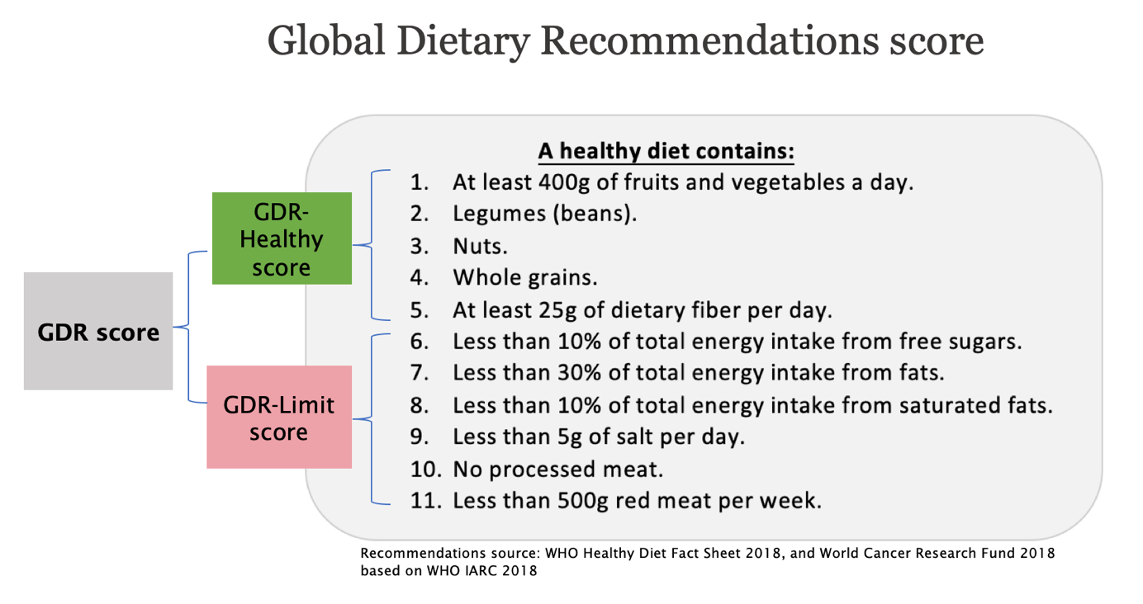

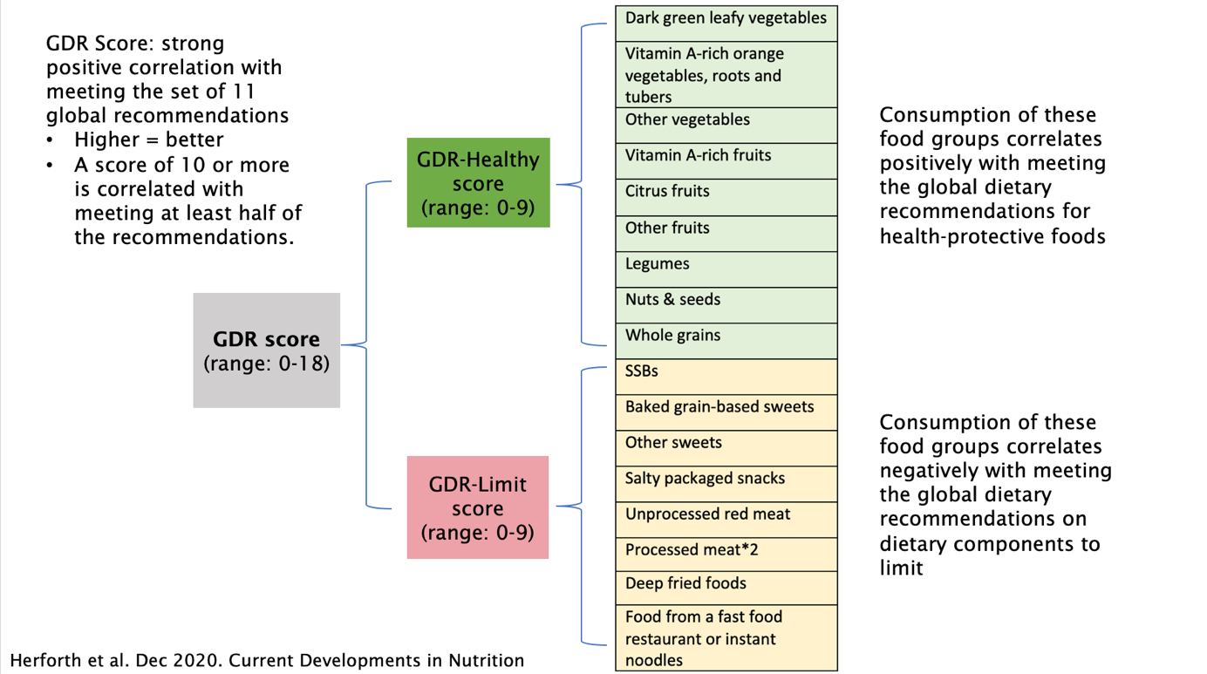

**References:**

1. Herforth, A. W., Wiesmann, D., Martínez-Steele, E., Andrade, G., & Monteiro, C. A. Introducing a Suite of Low-Burden Diet Quality Indicators That Reflect Healthy Diet Patterns at Population Level. *Current Developments in Nutrition*, 2020; 4(12), nzaa168.
2. International Agency for Research on Cancer (IARC). Red and processed meat. IARC monographs on the evaluation of carcinogenic risks to humans. Vol. 114. Lyon (France): IARC; 2018. https://monographs.iarc.fr/wp-content/uploads/2018/06/mono114.pdf.
3. World Cancer Research Fund/American Institute for Cancer Research. Continuous Update Project expert report 2018. Recommendations and public health and policy implications https://www.wcrf.org/sites/default/files/Recommendations.pdf.
4. WHO. Healthy Diet Fact Sheet no. 394. Geneva (Switzerland): WHO; 2018.
5. WHO and UNICEF. Indicators for assessing infant and young child feeding practices: definitions and measurement methods. Geneva: World Health Organization and the United Nations Children’s Fund (UNICEF), 2021.

1. Martin-Prevel Y, Arimond M, Allemand P, Wiesmann D, Ballard TJ, Deitchler M, Dop MC, Kennedy G, Lartey A, Lee WTK, and Moursi M on behalf of the Women’s Dietary Diversity Project (WDDP) Study Group. (2017). Development of a Dichotomous Indicator for Population-Level Assessment of Dietary Diversity in Women of Reproductive Age. Current Developments in Nutrition, 1(12) cdn-117. <https://doi.org/10.3945/cdn.117.001701>

   See also: FAO. 2021. Minimum dietary diversity for women (MDD-W). Rome. <https://www.fao.org/documents/card/en/c/cb3434en>
2. Herforth, A. W., Wiesmann, D., Martínez-Steele, E., Andrade, G., & Monteiro, C. A. (2020). Introducing a Suite of Low-Burden Diet Quality Indicators That Reflect Healthy Diet Patterns at Population Level. Current Developments in Nutrition, 4(12), nzaa168. <https://doi.org/10.1093/cdn/nzaa168>
3. Formerly published as “GDR-Healthy”
4. Formerly published as “GDR-Limit”
5. Indicators for assessing infant and young child feeding practices: definitions and measurement methods. Geneva: World Health Organization and the United Nations Children’s Fund (UNICEF), 2021.